(Approx. 990 words)

Does the Control Panel still exist?
By Phil Sorrentino, Secretary & Newsletter Contributor
Sun City Center Computer Club
https://scccomputerclub.org/
philsorr (at) yahoo.com

Good question. When Settings appeared in Windows 8 in 2012, it looked like Microsoft may have been laying the groundwork for moving most of the Control Panel features over to Settings. That may be true, but here we are, eleven years later, and the Control Panel still exists. The control panel exists along with the settings in Windows 10 and 11, though the organization of each changes slightly compared to Windows 10 and 11.
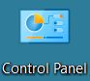
So, how did we get here? Just a little history. Our very old friend Control Panel has been part of Microsoft Windows since version 1.0. Each of the early versions introduced new Applets (small software applications). Being much younger, the Settings App was first released with Windows 8. In Windows 8, the “PC Settings” App was designed as a simplified area optimized for touchscreen devices. It included a small portion of Control Panel functionality on a two-panel full-screen interface. Windows 8.1 improved the Settings App by including capabilities previously part of the Control Panel and providing a redesigned organization. It also added a small “Control Panel” link at the bottom of the left panel to allow users to open the Control Panel. Unfortunately, that helpful link did not remain in later generations of Settings. (However, you can always get to the Control Panel by typing “Control” into the search bar in the taskbar.) Settings categories change with each generation released. In the first generation Settings App, the categories were: PC and Devices, Accounts, OneDrive, Search and Apps, Privacy, Network, Time and Language, Ease of Access, Update and Recovery, and finally Activate Windows (which shows up only if Windows isn’t activated).
The second generation of the Settings App was included with all releases of Windows 10, 2016, 2019, and 2022. It included more capabilities that were previously parts of the Control Panel. Windows Update, part of the Control Panel before Windows 10, was now exclusively a part of Settings. This second version brought some changes to the categories. It contained the following: System, Devices, Phone, Network & Internet, Personalization, Apps, Accounts, Time & Language, Gaming, Ease of Access, Search, Cortana, Privacy, Update & Security and finally Mixed Reality (but only if a connected device meets HoloLens requirements).
The third generation of the Settings App is found in Windows 11. This version has been significantly redesigned with a new layout and updated icons. (A persistent navigation sidebar has also been added, providing links to various settings capabilities within the App.) The Windows 11 Settings App now contains the following categories: System, Bluetooth & Devices, Network & Internet, Personalization, Apps, Accounts, Time & Language, Gaming, Accessibility, Privacy & Security, and Windows Update.
The control panel is not apparent or easily found on Windows 10 or 11. If you don’t have the Control Panel icon on your desktop, you can use the Search bar on the taskbar to find it. (Though it doesn’t seem obvious or intuitive, in either Windows 10 & 11, if you want to put the Control Panel icon on your desktop, go to Settings-Personalization-Themes, select “Desktop icon settings,” and then check the box next to Control Panel and click Apply.) Control Panel seems to be relegated to the background in Windows 10 and 11. Though there are some differences, once you get to the Control Panel in either version, it seems to work just about the same.
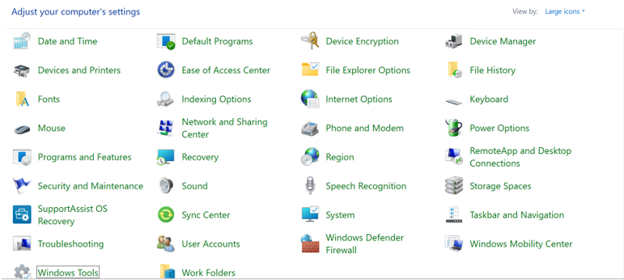
Windows 11 Control Panel
“Settings” is much more prominent than Control Panel on Windows 10 and 11. On Windows 10, Settings is immediately available after the Start button is left-clicked. (See the gear icon?) If you right-click the start button, you will also see an entry for “Settings” in the menu. Either method gets you to the same Settings App. On Windows 11, the Settings (gear) icon is probably in the Pinned area of the start menu. If you don’t see it there after you left-click the start button, it might be on a second-level display of the Pinned icons. If there are two dots on the right side of the display of icons, click the smaller one (or the arrow that appears when you hover over the dot). That will reveal another group of “Pinned” icons. If it is there, you are set. If it is not present, click “All apps >” and you will see it in the “All apps” alphabetical list. Right-click Settings and click “Pin to start,” it will be easier to find the next time you need it. You can also click “More” and then “Pin to taskbar” to pin it to the taskbar if you expect to use it often. (You will also notice “App settings” next to a gear icon. This will take you to the “Apps – Installed Apps – Settings” screen, which provides some general control over apps.)
On Windows 11, no matter how you get to the Settings App, the persistent navigation sidebar controls the action. The left panel is the Navigation panel, and the right panel presents the capabilities selected in the navigation panel. Initially, “Settings” starts with “System” in the navigation panel, and the System capabilities are shown in the right panel. Choosing a capability by clicking on a capability in the right panel gets you to the capabilities presented on the next screen. After you reach a capabilities screen, clicking the <- arrow next to “Settings” at the top left corner will get you back to the Settings screen. (This “back arrow” is used throughout the Settings App to get you back to the previous screen.)
So, for now, at least, the Control Panel is still an integral part of Windows 10 and 11, though it seems that without the Search bar, it might not be easy to find. Maybe, as time passes and we get updates, more Control Panel capabilities will be moved into Settings. Control Panel may eventually disappear, but only Microsoft knows what the future holds for Control Panel.

